4.2 ARCHITECTURE DIAGRAM
Every time the commuter uses the AICTSL Services he/she has to tap the card with in-built Reader that will be the front end of our architecture. The passive reader gets power from the reader and reader reads the tag ID. After reading the tag ID, here comes the use of interfacing modules like Microcontroller, GSM/GPRS. Reader interfaces with Microcontroller and passes this ID to microcontroller. Microcontroller will be programmed in such a way so as to send data i.e. tag id, service id & location to the application server with the help of GSM/GPRS module. The entire Business Logic (processing) is made to get executed on Application Server. Based on the user data received from Microcontroller a program would execute on application server that will be connected with Database server by java database connectivity (JDBC). This program would check for validity & update the balance in the database.
THE HARDWARE COMPONENTS REQUIRED ARE
- Em-18 RFID module - It consists of reader and tag of frequency 125Khz
- Arduino ATmega2560
- 16x2 Alphanumeric LCD
- Digital Odometer
- SIM 900 GSM/GPRS Module
- Electronic Buzzer
- Breadboard
Arduino ATmega2560
Arduino is an open-source computer hardware and software company, project and user community that designs and manufactures microcontroller-based kits for building digital devices and interactive objects that can sense and control objects in the physical world.
The Mega 2560 is a microcontroller board based on the ATmega2560. It has 54 digital input/output pins (of which 15 can be used as PWM outputs), 16 analog inputs, 4 UARTs (hardware serial ports), a 16 MHz crystal oscillator, a USB connection. It contains everything needed to support the microcontroller; simply connect it to a computer with a USB cable or power it with a AC-to-DC adapter or battery to get started.

We have selected Arduino 2560 because it is simple and has clear programming environment.
- Inexpensive - Arduino boards are relatively inexpensive compared to other microcontroller platforms. The least expensive version of the Arduino module can be assembled by hand, and even the pre-assembled Arduino modules cost less than $50.
- Cross-platform - The Arduino Software (IDE) runs on Windows, Macintosh OSX, and Linux operating systems. Most microcontroller systems are limited to Windows.

Interfacing of LCD wih arduino 2560.
The JHD162A has 16 pins and can be operated in 4-bit mode or 8-bit mode. Here we are using the LCD module in 4-bit mode.

Figure 4.2 : Pin Diagram of LCD

Pin1(Vss) :Ground pin of the LCD module.

Pin2(Vcc):+5V supply is given to this pin

Pin3(VEE):Contrast adjustment pin. This is done by connecting the ends of a 10K potentiometer to +5V and ground and then connecting the slider pin to the VEE pin. The voltage at the VEE pin defines the contrast. The normal setting is between 0.4 and 0.9V.

Pin4(RS):Register select pin. The JHD162A has two registers namely command register and data register. Logic HIGH at RS pin selects data register and logic LOW at RS pin will select command register. If we make the RS pin HIGH and put a data on the data lines (DB0 to DB7) it will be recognized as a data. If we make the RS pin LOW and put a data on the data lines, then it will be taken as a command.

Pin5(R/W): Read/Write modes. This pin is used for selecting between read and write modes. Logic HIGH at this pin activates read mode and logic LOW at this pin activates write mode.

Pin6(E): This pin is meant for enabling the LCD module. A HIGH to LOW signal at this pin will enable the module.

Pin7(DB0) to Pin14(DB7): These are data pins. The commands and data are put on these pins.

Pin15(LED+): Anode of the back light LED. When operated on 5V, a 560 ohm resistor should be connected in series to this pin. In arduino based projects the back light LED can be powered from the 3.3V source on the
arduino board.

Figure 4.3 : Interfacing of LCD with Arduino

RS pin of the LCD module is connected to digital pin 12 of the arduino. R/W pin of the LCD is grounded. Enable pin of the LCD module is connected to digital pin 11 of the arduino. In this project, the LCD module and arduino are interfaced in the 4-bit mode. That means only four of the digital input lines( DB4 to DB7 of the LCD are used). This method is very simple, requires less connections and you can almost utilize the full potential of the LCD module. Digital lines DB4, DB5, DB6 and DB7 are interfaced to digital pins 5, 4, 3 and 2 of the Arduino. The 10K potentiometer is used for adjusting the contrast of the display. 560 ohm resistor R1 limits the current through the back light LED.

Program…

#include<LiquidCrystal.h>
LiquidCrystal lcd(12, 11, 5, 4, 3, 2); // sets the interfacing pins
void setup()
{
lcd.begin(16, 2); // initializes the 16x2 LCD
}
void loop()
{
lcd.setCursor(0,0); //sets the cursor at row
0 column 0
lcd.print("16x2 LCD MODULE"); // prints 16x2 LCD MODULE
lcd.setCursor(2,1); //sets the cursor at row
1 column 2
lcd.print("HELLO WORLD"); // prints HELLO WORLD
}
After uploading the program hello world gets diaplayed on the LCD.

Interfacing of rfid reader with arduino atmega2560
RFID is Radio Frequency Identification. An RFID reader is used t read RFID tags (which contain certain unique data stored in a chip). An RFID reader and an RFID tag, both have a coil surrounding them. When an RFID tag is shown near an RFID Reader, it collects the unique tag data (a combination of digits and characters) from the RFID tag.

Figure 4.4 : Interfacing of Reader with Arduino

We have to connect Ground Pin of RFIDreader to Ground Pin of Arduino. We are using the Software Serial Library of Arduino which enables digital pins to be used in serial communication. We have used pin 11 as the Rx of Arduino.

Program
#include <SoftwareSerial.h>
SoftwareSerial mySerial(9, 10);
void setup()
{
mySerial.begin(9600); // Setting the baud rate of Softw
are Serial Library
Serial.begin(9600); //Setting the baud rate of Serial
Monitor
}void loop()
{
if(mySerial.available()>0)
{
Serial.write(mySerial.read());
}
}

After uploading the program the tag id will be displayed on the serial monitor.

SOFTWARE SPECIFICATIONS

- Net Beans IDE 7.0.1 as an integrated development environment for developing Java based web application and an interface that will be used for receiving tag ID along with vehicle Identification number and current location. To check whether the provided tag ID is valid or not we need to manage a database of passengers containing their tag Id along with their personal credentials.
- Oracle 10g for storing data as our primary database that will be holding some interrelated relations. We will be using pl/sql for performing database transactions.
- LDAP which is light weight protocol for accessing directory servers .It is a hierarchical object oriented database. It can be used for storing the data that has more read operations as compared to write operation in a secure manner. We will be using it for saving the fair information between different locations.
- JDBC/ODBC driver (Platform independent) will be used for Oracle database connectivity to advanced Java application.
- A web server, Apache HTTP Server 2.2 is used to support server-side programming language and for authentication purpose.
- GPRS modem AT commands for establishing TCP connection to server for receiving and sending of data to or from server.
- We will be connecting to LDAP server using JNDI (Java Naming and Directory Interface) in Java.

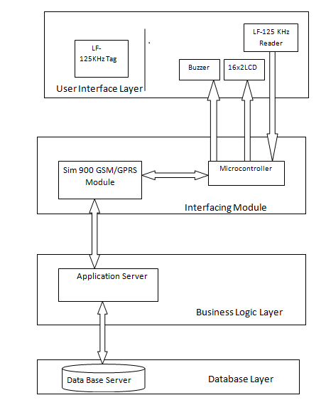
Figure 4.5: Architecture Diagram for the System

  - FLOW DIAGRAMS
4.3.1 FLOW DIAGRAM FOR I- BUS AND CITY BUS
The flow diagram for I-bus and City bus is shown in figure 4.3.
- The traveler enters the bus and taps the card against the reader installed at the gate of the bus (I-bus and city bus). The reader reads the card ID. It is interfaced with the microcontroller which in turn is interfaced with the GSM/GPRS module.
- The microcontroller sends tag ID and service Id to the Application server wirelessly through the GSM/GPRS module.
- The Application server fetches the details from the database for the desired tag ID and service ID. It checks for the validity of the cash card. Two situation arise:
- If validity > =current date, the Application server sends the status to microcontroller through GSM/GPRS module.
- If Validity < current date or validity = NULL, it checks for the validity of the cashless card. Again two situation arise-:
- If balance > minimum balance, the Application server deducts the balance from the card and sends the appropriate status to microcontroller through GSM/GPRS module.
- If balance < minimum balance, the Application server sends the appropriate status to microcontroller through GSM/GPRS module. The microcontroller than generates the alarm.

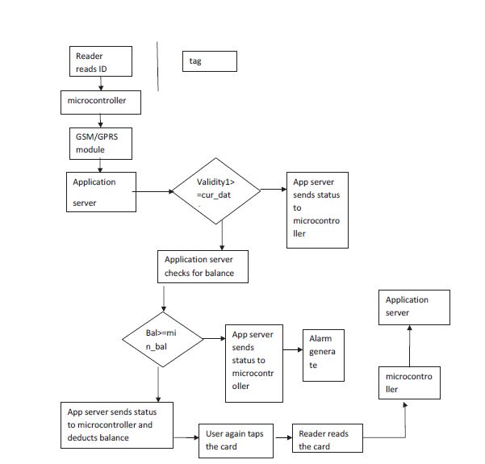
Figure 4.6: Flow Diagram for I-Bus and city bus

HOW IS THE BALANCE DEDUCTED FROM THE CASHLESS CARD IN CITY BUS AND I-BUS
A commuter can use his cashless card while travelling in the bus and the fare will be deducted from his card accordingly. There are various ways through which he can use his cashless card to travel in bus, they are –
- The user enters the bus, taps his card and enters the destination. For that the reader will have a unique button corresponding to each destination and the user will press the desired button.
But there are two problems with this
- The user can enter the wrong destination
- Due to excessive crowd in the bus the conductor may not be able to keep track of all card holders, and some card holders may travel without tapping their card.
- The conductor enters the destination of the user.
This approach has two problems-
- The user can tell wrong destination as he knows that conductor won’t remember
- Manual work will be increased
- It will be a time consuming process in case of excess crowd
3.
A
C

B

Figure 4.7: Bus stops
The 3rd method can be explained with the help of figure 4.4.
Here A is the boarding stop, C is the final stop of the bus and B is the destination stop of the commuter. When the commuter enters the bus, he will tap his card and the fare will be deducted which is the fare from A to C. The commuter will again tap his card when he leaves the bus and then the fare from B to C will be added to his card. The only limitation with this method is that he will have to have a minimum balance of Rs.25method number 3 is found to be more efficient among all and we will be working on this method.

    - FLOW DIAGRAM OF TELERICKSHAW
The traveler taps the card against the reader installed in the Tele-rickshaw. The reader reads the card ID. It sends the Id to the microcontroller interfaced with it. The microcontroller is interfaced with the odometer. At the end of the trip the user
again taps the card and the distance is calculated by microcontroller with the help of odometer. The fare is deducted accordingly and is displayed on the LCD

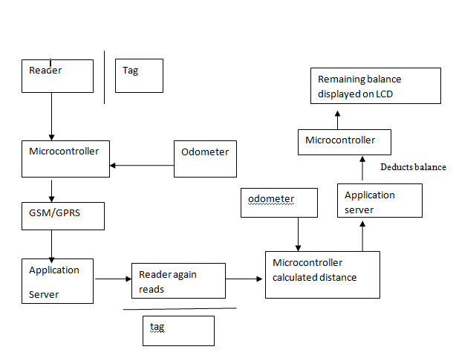
Figure 4.7: Flow Diagram for Tele Rickshaw

    - FLOW DIAGRAM OF I-RIDE

- The traveler taps his card in the AICTSL office. The reader reads the tag ID and sends send it to the microcontroller interfaced with it.
- The microcontroller sends this tag ID and service ID to the Application server wirelessly through the GSM/GPRS module and records the current time.
- When the traveler returns he again taps the card against the reader which again sends the service ID and tag ID to the microcontroller. The microcontroller saves the current time and sends it to the application server along with service ID
- and tag ID.
- The Application server fetches the details from the database for the desired tag ID and service ID, calculates the time difference and fare and deducts the fare accordingly.
- It then sends the remaining balance to the microcontroller which then displays on the LCD.
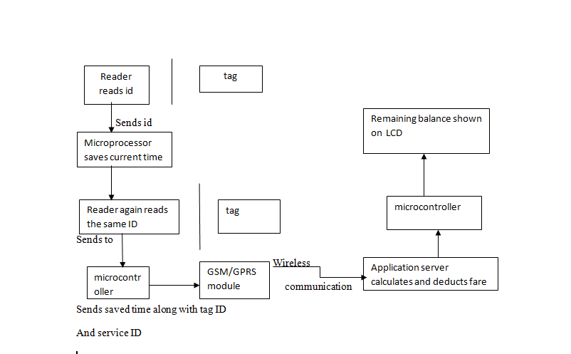
Figure 4.8: Flow Diagram for I-Ride

4.4 ACTIVITY DIAGRAM
4.4.1 ACTIVITY DIAGRAM FOR I-RIDE
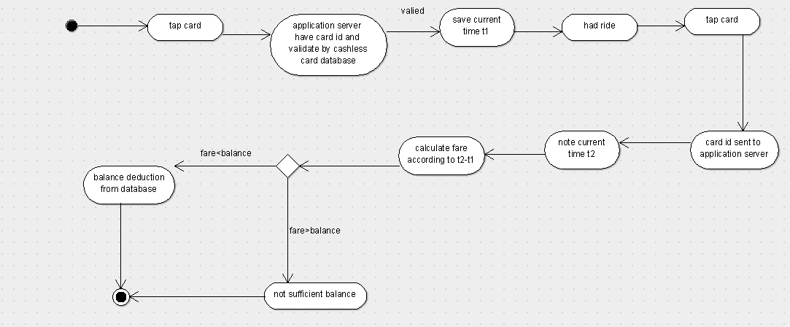
Figure 4.8: Activity Diagram for I-Ride

4.4.2 ACTIVITY DIAGRAM FOR BUS
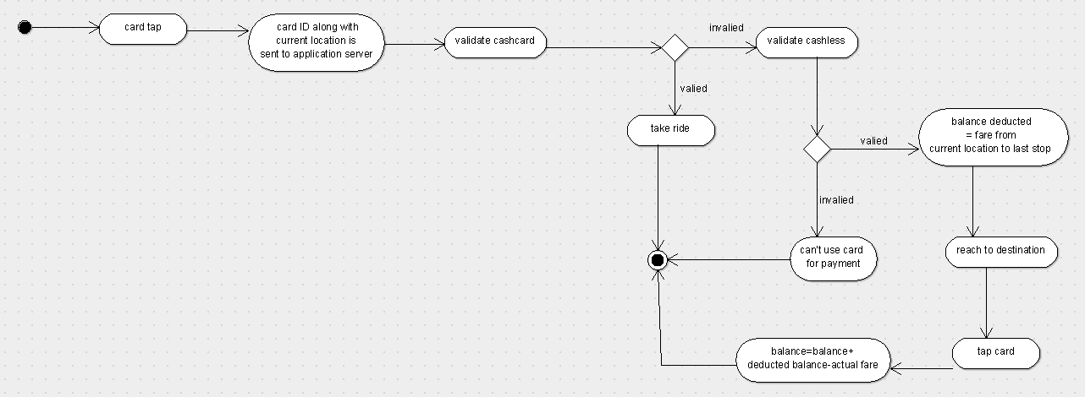
Figure 4.9: Activity Diagram for I-Bus and City Bus

4.4.2.1 VALIDATE CASH CARD
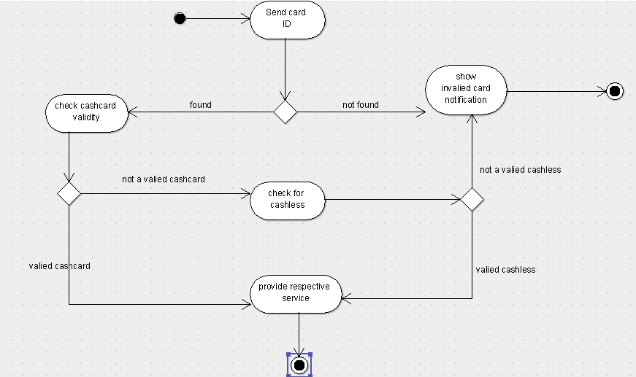
Figure 4.10: Activity Diagram for Cash Card Validation

4.4.3 ACTIVITY DIAGRAM FOR TELERICKSHAW

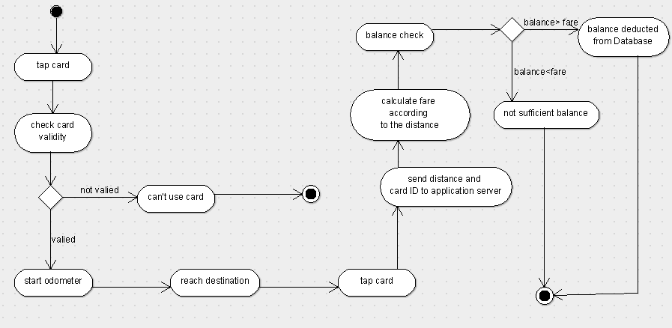
Figure 4.11: Activity Diagram for Tele Rickshaw

CHAPTER 5: CONCLUSION

5.1 WORK CARRIED OUT IN PHASE-1
- We analyzed the problems with the AICTSL Services and the major problem among them was the inconvenience to the users that he can't use the card of city bus in I-bus also. We came up with a solution where a single card can be used in all kinds of services.
- We will be designing a multipurpose card based on RFID Technology which will be a Hybrid Card (a combination of Cash Card and Cashless Card). The RFID Card is taped against a Reader and the processing is done.
- We also analyzed the flow of certain processes which includes the working of RFID card, what happens when it is taped against a reader, why do we need Microcontroller, how the location of bus and Telerickshaw is tracked and finally how the balance is deducted.
- We also developed the Database needed for the project and what information about the user and the services should be present in the database.
- We also designed the Architecture for our project which would be referred frequently for developing the prototype.
- After analyzing the whole scenario and the technologies, we can conclude that this project is feasible and is sellable and the whole control lies in the hands of AICTSL Authorities. Apart from this, by developing this project, the whole revenue goes to the AICTSL which is then distributed among different operators accordingly.

5.2 WORK TO BE CARRIED OUT IN NEXT PHASE
We will be buying a RFID module with frequency 125 kHz. The tag will be passive that is, it will be tapped against the reader and will take power from it.Interfacing between microcontroller and the reader is done with the help of UART and the interfacing between microcontroller and application server is done with the help of RS232 .The programming of microcontroller will be done in embedded C.Microcontroller will be programmed in such a way that it sends the tag ID received from reader, time, distance and service ID to the Application server.
Application server is server where java applications will run. It will receive tag ID, service ID or time and it fetches data from the database server. It then performs the query execution like calculating fare, checking time validity, checking blocked cards, adding new user balance deduction etc.
We will be having GSM/GPRS module for wireless connectivity between microcontroller and the application server. Also it will be used for tracking the location of bus when a user uses his cashless card to travel in bus and sends this location to the application server which deducts the fare according to the stop of the bus.We will be buying a RFID module with frequency 125 kHz. The tag will be passive that is, it will be tapped against the reader and will take power from it.Interfacing between microcontroller and the reader is done with the help of UART and the interfacing between microcontroller and application server is done with the help of RS232 .The programming of microcontroller will be done in embedded C. Microcontroller will be programmed in such a way that it sends the tag ID received from reader, time, distance and service ID to the Application server.
Application server is server where java applications will run. It will receive tag ID, service ID or time and it fetches data from the database server. It then performs the query execution like calculating fare, checking time validity, checking blocked cards, adding new user balance deduction etc.
We will be having GSM/GPRS module for wireless connectivity between microcontroller and the application server. Also it will be used for tracking the location of bus when a user uses his cashless card to travel in bus and sends this location to the application server which deducts the fare according to the stop of the bus.

References

[1]. D. C. Karaiskos , P. Kourouthanassis and G.M. Giaglis , "User acceptance of pervasive information systems : evaluating an RFID ticketing system ", in Proceedings of ECIS , Athens, Greece , 2007
[2]. J.L. Wang , "Privacy and ethical issues in location-based tracking systems", in Proceedings of IEEE International Symposium on Technology and Society , Illinois , USA,2009
[3]. A-R Sadeghi , I. Visconti , and C. Wachsmann . User privacy in transport systems based on RFID e-tickets.
[4]. Mr. Rahul Shrouti , Technical Manager , AICTSL.
[5]. Wal-Mart spells out RFID vision , RFID Journal 2003 . Retrieved 8-09-2010 , from http://www.rfidjournal.com/article/purchase/463

